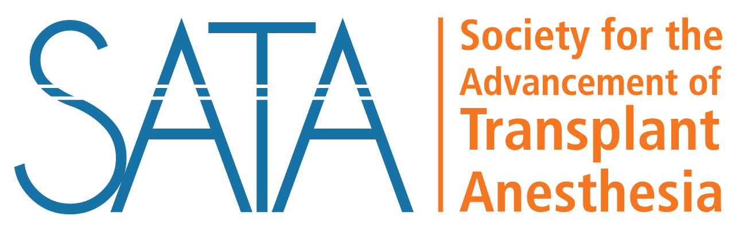

Chambers DC, Zuckermann A, Cherikh WS, Harhay MO, Hayes Jr D, Hsich E, Khush KK, Potena L, Safavarte A, Singh TP and Stehlik J. The International Thoracic Organ Transplant Registry of the International Society for Heart and Lung Transplantation: 37th adult lung transplantation report- 2020; focus on deceased donor characteristics. Article In Press. Journal of Heart and Lung Transplantation.

https://www.jhltonline.org/action/showPdf?pii=S1053-2498%2820%2931661-2

Abstract: “Almost 70,000 adult lung transplant procedures have been reported to the International Society for Heart and Lung Transplantation (ISHLT) International Thoracic Organ Transplant (TTX) Registry since its inception, each one the result of the selfless kindness of a grieving donor family. With each year's report, we provide more detailed analyses on a particular focus theme important to recipient outcomes. Since 2013, these have been donor and recipient age, retransplantation, early graft failure, indication for transplant, allograft ischemic time, multiorgan transplantation, and donor and recipient size matching. ^{1,2,3,4,5,6,7}
The goal of this year's report is to focus entirely on changes in donor factors over the past 3 decades and to identify important donor characteristics and transplant processes that may influence post-transplant outcomes. Because of small numbers, heart–lung donor characteristics and transplant outcomes have not been included. This 37th annual adult lung transplant report is based on data submitted to the ISHLT TTX Registry on 67,493 adult recipients of deceased donor transplants between January 1, 1992 and June 30, 2018. In response to a changing regulatory environment, the ISHLT TTX Registry is undergoing an update in data acquisition, and the patient cohort examined in this report is therefore derived from the same data source or datasets as that examined in the 2019 annual reports. ^{2,8,9,10}
We refer the reader to the 2019 report for the detailed description of the baseline characteristics of the cohort and additional core analyses not directly related to the focus explored in this year's report.”

Comments by Barbara Wilkey, MD:

This year’s report on Lung Transplantation from the ISHLT focuses on the changing characteristics of deceased donors over the past 30 years and how this may impact outcomes.
The report looks at trends from 1992 to 2018 involving approximately 75% of the world’s lung transplant volume. The information in this report is limited to adult lung transplants and does not include heart-lung transplants. Variable analysis is primarily univariate. Variables discussed are 1) Geographic location, 2) Age, 3) Gender, 4)Height, 5) BMI, 6) Cause of death, 7) Infectious disease status, 8) Substance use, 9) Diabetes (DM), 10) Hypertension (HTN) 11) Oxygen partial pressure (PaO2), and 12) Ischemic time.

Interestingly, the number of lung transplants performed annually has increased but the proportion performed in North America has decreased. The age of donors has increased with a median donor age of 51 in Europe. Donors are more likely to be cytomegalovirus or Epstein Barr positive, more likely to be female, shorter, and have a higher BMI in the present era compared with previous. The median donor PaO2 has decreased from 424 to 409 over the past 20 years. Cause of death in Europe has been primarily stroke. In North America head trauma is the number one cause of death with a recent notable increase in anoxia. The proportion of donors with a greater than 20 pack year smoking history has decreased (35% to 10%) while the proportion of donors with a history of daily alcohol intake of two drinks or more, a history of cocaine use (10 to 20%) or a history of non-intravenous street drug/prescription drug use (20% to 50%) has increased. The proportion of donors with DM has increased from 2-3% to 10% while the proportion of donors with hypertension has increased from 10% to 25%.

Variable effect on survival is outlined in Table 1. Some striking contributors are presence of DM, HTN and ischemic time. Overall, longer ischemic time seems to be protective with greater long-term survival from donor ischemic times four hours or greater (70 vs 65%). Presence of diabetes decreased one-year survival from 85 to 81.3% and five-year survival from 67 to 63%.

This report also looked at donor variables and freedom from Bronchiolitis Obliterans Syndrome (BOS). Recipients with donors less than 35 years old are less likely to develop BOS than those with donors 50 years or older. Alcohol consumption in the donor is associated with less freedom from BOS whereas ischemic times of four hours or more are associated with greater freedom from BOS. Donor PaO2, smoking, cocaine or other drug us, DM and HTN had no association with freedom from BOS.

Table 1: Donor Variable Effect on Recipient Survival
 | 12-month Survival | 5-year Survival
Age | Minimal decrease with donors over 50 years old. | No difference.
Cause of Death | Higher survival seen with anoxia and lowest with CVA but not statistically significant. | No difference.
PaO2 | No effect. | No effect.
Substance Use | Smoking: Lower survival.  Alcohol: No effect.  Cocaine: Lower survival.  Non-IV street or prescription: No difference. | Smoking: Lower survival.  Alcohol: No effect.  Cocaine: Lower survival.  Non-IV street or prescription: Lower survival.
DM | Lower survival. | Lower survival.
HTN | Lower survival. | Lower survival.
Ischemic Time and Age | Ischemic time 4 hours or longer and age 50 or greater: Lower survival when compared to donors less than 35 years old. | No effect.
Ischemic Time and HTN | Greatest survival seen with ischemic times 4 hours or longer and no HTN. | Greatest survival seen with ischemic times 4 hours or longer and no HTN.

In conclusion, this year’s report from the ISHLT on lung transplantation brings to light factors, such as diabetes mellitus and systemic hypertension, that are not traditionally heavily weighted in donor selection but may have a significant impact on outcomes. Additional study is warranted and, perhaps, a change in optimal donor criteria suggested.

